**Professional Smart Card**

SYED NATIQ HUSSAIN SHAH

YASIR IQBAL



DEPARTMENT OF COMPUTER SCIENCES

COMSATS UNIVERSITY ISLAMABAD,

ATTOCK CAMPUS

**SESSION 2018-2022**

**Professional Smart Card**

***Undertaken By:***

**SYED NATIQ HUSSAIN SHAH**

CIIT/SP18-Bcs-001/ATK

**YASIR IQBAL**

CIIT/SP18-Bcs-015/ATK

***Supervised By:***

M. JAMAL AHMED

A DISSERTATION SUBMITTED AS A PARTIAL FULFILLMENT OF THE REQUIREMENTS FOR THE DEGREE OF BACHELOR OF SCIENCE IN COMPUTER SCIENCE

DEPARTMENT OF COMPUTER SCIENCES

COMSATS UNIVERSITY ISLAMABAD,

ATTOCK CAMPUS – PAKISTAN

**SESSION 2018-2022**

UNDERTAKEN

We certify that this is my/our own work. The work has not, in whole or in part, been presented elsewhere for assessment. Where material has been used from other sources it has been properly acknowledged. If this statement is untrue, we acknowledge that we will have committed an assessment offence and shall be liable to punishable action under the plagiarism rules of HEC.

_____________________ ____________________

Syed Natiq Hussain Shah Yasir Iqbal

SP18-BCS-001 SP18-BCS-015

Dated: _________ Dated: _________

**FINAL APPROVAL**

Certified that we have read this project report submitted by Mr. (Syed Natiq Hussain Shah/ Yasir Iqbal) and it is, in our judgment, of sufficient standard to warrant its acceptance by Department of Computer Science, COMSATS University Islamabad, Attock Campus, for the (BS degree) in Computer Science.

***Committee:***

1. External Examiner ____________________________

(Examiner Name)

Designation

University Name

2. Supervisor ____________________________

(M. Jamal Ahmad)

3. Chairperson ____________________________

(Chairperson Name)

4. Dean/Director ____________________________

(Dean/Director Name)

**DEDICATION**

We would also like to thank M. Jamal Ahmed for his guidance to work hard. We have found him very helpful in the discussion related to our project. His critical comments on our work have made us think about new ideas. We are grateful to Allah Almighty who provided us every kind of resources to make this project for the benefit of the mankind.

**ACKNOWLEDGMENT**

In the Name of Allah, the Most Gracious,the Most Merciful. First, we would like to thank our parents and teachers who supported us in all times, both financially and morally.

We would also like to thank M. Jamal Ahmed for his guidance to work hard. We have found him very helpful in the discussion related to our project. His critical comments on our work have made us think about new ideas. We are grateful to Allah Almighty who provided us every kind of resources to make this project for the benefit of the mankind.

**PROJECT BRIEF**

PROJECT NAME PROFESSIONAL SMART CARD

ORGANIZATION NAME COMSATS UNIVERSITY ISLAMABAD

ATTOCK CAMPUS

OBJECTIVE TO LINK BUSSINESS & CLIENTS TOGETHER

VIRTUALLY

UNDERTAKEN BY SYED NATIQ HUSSAIN SHAH (SP18-BCS-001)

YASIR IQBAL (SP18-BCS-015)

SUPERVISED BY M. JAMAL AHMAD

LECTURER

COMPUTER SCIENCE

COMSATS UNIVERSITY ISLAMABAD

ATTOCK CAMPUS

Started On 20 FEBUARARY, 2021

Completed On 10 APRIL, 2021

COMPUTER USED HP & DELL

SOURCE LANGUAGE JAVA, PYTHON, XML

OPERATING SYSTEM WINDOW 10

TOOLS USED ANDRIOD STUDIO, FIREBASE

**ABSTRACT**

Professional Smart card is an android application, being a growing nation, it is needed to digitize the services of professional card. When somebody attends a workshop or seminar, he receives many cards that he will put into his pocket. After that he will take the pictures of cards instead of keeping them all the cards at all time in their pockets. Whenever the user wants to contact some person, he will thoroughly search either the images of all cards in his mobile gallery or in his pocket, that will not only waste the user time but also it will be a headache to search for a number through this process. This android application will not only reduce this effort but also provide a mechanism where user can scan the card and will save the phone number in the contact list. This application will also provide if the card has QR code then using the QR code, one can get the more detail of the card holder like restaurant details, doctor visits, businessmen etc. In this app the card holder professionals as well as normal users both will be treated. The application algorithm powered by AI learning algorithm will increase the accuracy as it scans the cards. Furthermore, we can design our smart card; make it virtual and Using AI algorithm we can share to a particular vicinity area so that other users can see the new products etc.

**TABLE OF CONTENTS**

Introduction 12

**1.1 Introduction** 13

**1.2 Objective** 14

**1.3 Modules** 14

**1.4 Problem statement** 15

**1.5 Conclusion** 15

Literature Review 17

**2.1Motivation and Scope** 18

**2.2 Related Work** 19

2.3 Comparison Table 20

Proposed Methodology 22

3.1 Non-Functional requirements 23

3.1.1 Performance 23

3.1.2 Response time 23

3.1.3 Security 23

3.1.4 Usability 23

3.1.5 Reliability 23

3.1.6 Recoverability 24

3.2 Functional requirements 24

3.3 Proposed Solution 24

3.4 Conclusion 25

Project Design 27

4.1 Activity Diagram 29

4.1.1 Activity Diagram of App 30

4.2 Use Case Diagram 31

4.3Sequence Diagram 33

4.3.1 Sequence Diagram of User 33

4.4 Context Diagram 35

4.5System Architecture Diagram 36

4.6 Conclusion 37

**List of Tables**

Table 1: Comparison Table 20

**List of Figures**

Figure 1: Scrum Model Diagram 28

Figure 2: Activity Diagrams 30

Figure 3: Use Case Diagram 32

Figure 4: Sequence Diagram of User Login 33

Figure 5: Sequence Diagram of Registered User 34

Figure 6: Context Diagram 35

Figure 7: System Architecture Diagram 36

**Chapter 1**

# Introduction

**1.1 Introduction**

Most of the android users feel uncomfortable for keeping so much physical cards in their wallets. The android users are from the modern generation. They want to deal every problem in smart way. So here is the solution if someone wants to store the card to get service later. The user can take the picture, save into phone gallery and throw card into dustbin. Using this application, we can save that phone number directly that is printed on the card in the phonebook. In this application, if organization changes location, they don’t have to update their cards by wasting the previous ones. They should not inform their old users about new location. They only have to change the location online in application and the notification will be sent to the users. Like a WhatsApp or other social media group, user can solve any problem by taking help from the community using the community chat service in the application. The world is digitalizing and everything is shifting online so as the business but the communication and marketing strategy is same sharing paper cards for the exchange of contacts so why not to change this trend also and develop a way to digitalized this thing by using digital cards which are easy to manage and handle and save time also. It also prevents the headache of carrying paper card bundles. Whenever the contact gets changed or updated it will also update it in the smartcard data. User can also find social media profiles of the card using QR code and given information. Physical cards are difficult to design and make copies and share with customers using different agents, in this way many resources are used. But in this application, Businessman can also upload their business card and can easily share with customer in very easy and cost saving steps. Based on location, this application will provide suggestions of the available businesses near customer location. As the user has the benefit of chat so the user can easily interact with the business community and get the queries solved without any worry or physical work. User can also get the nearby businesses according to his current location. User will also be shown recommendations based on his interests. Popular businesses are also shown to the user based on his current location. As user will have a profile so user can easily add his information there and can easily share it with others easily and if the information changes the user just have to update it on the profile everywhere else it would be automatically updated and a notification would be generated so that the user can easily be notified for the changes in the contacts saved. User will also be provided with the search option so that they can search the desired business or profile on the app and get all the relevant information about it that is stored on the app database. Search may be in the form of location or particularly name of the business or any keyword related to the business.User will also have the option to upload his business card on the app so that user can share it with other users registered on the app and with others across the app.

**1.2 Objective**

In this app we are providing the following services:

* User can easily create a profile in this application and can save different cards in their profiles which are shared by the different community.
* Businessmen can upload their digital card and share it with the customers.
* Using **QR** code we easily get profile of the person.
* Cards can be shared through email.
* User can hire the professional to get the online services.
* A community chat is available in which a person can take help from other experienced people in the respective community.
* A social circle will be defined using QR code.
* The phone numbers can be picked from the scanned image of the card and then can be saved in the phone directory.
* Suggest the cards of business which is running on the nearby vicinity so that two professionals can exchange it.
* User can scan three different cards simultaneously (if needed) and their data will be saved individually
* OCR based text reorganization is used to extract text from the card and then store only relevant information on the app contacts.
* Machine Learning algorithm makes the app more accurate as the number of cards that are scanned are increased.
* Recommendation system is used to recommend the users with the nearby businesses in the place.
* User can also search the nearby businesses of his interest and can also get contact details of them.

**1.3 Modules**

* Home Page: Main page of the application.
* OCR: For scanning and reading characters from the card.
* QR Code: For scanning QR code from the card (if available).
* Search: For Searching the contacts and businesses.
* Contacts: For saving and viewing saved contacts.
* Add Button: For uploading the cards of business.
* Profile: For User Profile management.
* Recommended System: Through ML cards/businesses areshown on home page for users.

**1.4 Problem statement**

As now adays people are too busy and they don’t have time for anything, so if they visit any seminar and they receive a card they put it in pocket and then later misplace it somewhere, so when they need it, they are unable to find it and in this way they loss the contact details of the business. For overcoming this problem, the user can use this app they can easily scan the card and save the contact details in the phone and then no problem if the card is lost. The user will also have the facility that they will have the updated information with them all the time when needed and no need to manually go and get the updated information from the business.Similarly, business can also maintain their profile on this app and provide services to the user. The user can chat through this app with the community and may get his queries solved without physically going there. Time is the main factor and no one has time in this busy life so if anyone want to meet any business professional, he/she has to take an appointment first and then they have to wait for their turn but through this app they can directly chat with them and doesn’t need to take appoint just message them and when they are free, they will contact you. For a business it is important to stay connected to their clients and provide them UpToDate information, this app provide them the facility for this. Users also face difficulty when they move to a new location because they don’t know nearby businesses of interest and they also don’t know that if there is any desired branch of that particular business, he/she needed that was previously there in the place he/she used to live, this app also solved this problem as it provides with the nearby business locations and provides locations for businesses of user interest. Users face the difficulty when the information get changed and they have not been informed and at the time of need they have to search all the information first in order to get in touch to the business. This problem is solved by this app as it keeps all the information updated and whenever any information changes it not only updates that information but it also notifies the user that information related to relevant user has been changed. As there were previously no options for the user to upload their own cards and they have to follow the given templates but in this app the user will have the freedom of uploading their own business cards so that they can share it with other users and outside the app also through email, Facebook, WhatsApp or any other platforms. User have the option to chat with the community which was not possible through paper cards until you have the phone number that is correct or unchanged but now through this app user can easily chat with community even the information is changed because it will also update it on the user end and user will not have to update it manually on its end.

**1.5 Conclusion**

As this app aims to provide facilities to the clients and business both, so it is beneficial for both of them. This app provides the contact saving and updating facility, it also provides the social media circle of the business (if available). It also provides with the facility of OCR and QR code scanning which help the users to easily transfer the information on paper card to the mobile phone with just one photo click instead of typing all the information and saving it manually into the mobile phone.User can also search nearby businesses in the area and can easily find the contact details of his required business instead of manually searching for the location and information. The user will also have the facility that if the business changes any of his information, it would also be updated on the user side as it was not possible if he has the business card instead of this app.User can easily maintain his own profile and can easily share it with other registered users across the app. Business can also upload their own business card templates and can customize their profile easily on the app.

Users also have the facility of chat which will help them to contact with business and get their queries solved as soon as possible. Users will also get a notification when any information is updated so that they should be aware of the changes time to time. User can also share their profile and information across the app through email, Facebook or any other platform.Recommendation system would recommend users with the businesses of his/her interest and will provide them suggestions. Users can have a search when they need to find any business in the location and the user can also search any business on the basis of city, location, name or keywords.At least this app is beneficial for user and business and provide all the necessary services that the person needs in regards of business contact management.

**Chapter 2**

# Literature Review

**2.1Motivation and Scope**

Printing the layout on the thick paper of the card is increasing the risk of ending the life of millions of trees annually. This adds the harmful effects on the environment especially in urban areas. Further, a recent research study shows that 88% of the customers throw their cards in the garbage within a week after receiving. The customer receives the card and forgets about that within days so the advertisement information will not fulfill its purpose. The amount of customer decreases and the businesses will start moving downwards. After analyzing these facts, we started thinking about this project. Why not convert the physical business card services into modern digital cards using the mobile application. Both team members are strongly concerned about this project. We found each other and started reading more articles and some research papers. As the time progressed our faith becomes stronger that it is the basic need to digitize the card service. Another thing is that if we are moving from one city to another city, we found many problems like changing the address and then distributing to the city is not easy but using this we can easily update and share it in near vicinity. We have also found that to communicate with the business you need updated information which paper cards doesn’t guaranty. We also found that the distribution of physical cards needs many resources like paper, employees, money, time, work and effort. So, we decided that why not to create an application that replaces these resources and saves time & money. User can just market his business through few clicks all around the places and updated information is shared among users. We have also found that if someone changes its location, he doesn’t have the access to the businesses there and user face the difficulty to locate a particular business or the branch of any business in that location so this app solved this problem by recommendation system and search option according to current location of the user or based on queries like city, name, keywords etc. We have also found out that now adays business cards have QR code on it and it has no benefit until and unless it is scanned through QR code reader but what can one do if he/she manages to read the QR code so we have provided the option for the users that they can scan the QR code and then directly the contact is saved on their contact list according to the information stored on the QR code. Previously the users were only able to follow a given templates for their business cards but now through this app they can upload their own design of cards and can share with others in few easy steps. We have also found that through paper cards only marketing purpose is done but that is also not done effectively, but through this app user can not only market their business but will also be connected to their clients directly and can chat with them and share their services to everyone and can handle their queries through this app easily and effectively. In shot this app will provide all the necessary things and platform a user and business need to make a successful business client relationship.

**2.2 Related Work**

1. **Wantedly People scan biz cards:**This is an android application in which physical cards can be scanned into phone and the contacts on it can be saved. The instant messages can be scan with the contacts.
2. **Haystack cards:** This is another android application having some relatable features in which digital business cards can be created in seconds. The cards can be shared through email and social media. Paper business card can be scanned into this application. This application auto updates the information in other devices as well.
3. **Switchit**:Switchit is a fun, innovative platform where you can create and share "Contactless" Digital Business Cards person-to-person or online. Create immersive, video-enabled digital business cards that visually connect people to your brand.

## 2.3 Comparison Table

**Table 1: Comparison Table**

|  |  |  |  |  |
| --- | --- | --- | --- | --- |
| **Functionality** | **Professional Smart Card (Proposed)** | **Haystack** | **Wantedly** | **Switchit** |
| Scan Cards  (Using OCR) | ✔ | ✔ | ✔ | ✔ |
| Scan Cards  (Using  QR-Code) | ✔ | ✖ | ✖ | ✖ |
| Social Circle | ✔ | ✖ | ✖ | ✖ |
| Nearby Business Suggestion | ✔ | ✖ | ✔ | ✔ |
| Notification of changes in information | ✔ | ✖ | ✖ | ✖ |
| Update Contacts | ✔ | ✔ | ✖ | ✖ |
| Community Chat | ✔ | ✖ | ✖ | ✖ |
| Business Search | ✔ | ✖ | ✔ | ✖ |

This table shows the comparison of existing apps with Professional Smart Card app. As you can clearly see that the existing apps are not providing all the facilities that our app provides. First of all, existing apps doesn’t support QR code scanner which is a plus point in our app. Existing apps doesn’t define social circle of the business that our app will provide. This app will provide notifications alert to the user for changes in contact details that no other provides. This app also provides chat option to the user which is not supported in other apps. In shot this table clearly highlights the features of existing apps and our app and it clearly defines the additional features that are provided to the users in our app that were not provided to them in the existing apps. Some additional features would also be added according to the need of the users that are based on location of the user. This table is just highlighting the overall difference of our app with the existing apps in the market.

**Chapter 3**

# Proposed Methodology

## 

## 3.1 Non-Functional requirements

These are the nonfunctional requirements which are described below.

### 3.1.1 Performance

The system will be able to perform all the tasks efficiently. All the features which we introduced in this app are performing all the functionality properly. As it depends on speed and app crash rate so this app is made up to the standard that it will load and work smoothly as well as its crash rate is about 01%, because all the things are tested first and then implemented on the system and after implementation it is again retested so that there is no issue in the performance of the app.

### 3.1.2 Response time

The system will be able to respond in few seconds. It is easy to install and take just few seconds to install if your internet availability is much better. It is a very responsive system and user will not have to wait for any function to respond because it is opened on first touch of the user. This app has a very quick response time.

### 3.1.3 Security

All the data will be secured as they will be done through private profiles. Data of all the users is secured in this app. Users are entered in this app with full security. As security is one of the prime factors of every user and we have kept this thing in mind while designing this app. We have used highly secured google firebase database to make sure that the user data is secure.

### 3.1.4 Usability

The application shall be easy enough to be used by any user. This application is helpful to all because business and clients both need to contact each other and stay connected. The interface of the app is kept simple so that a naïve user can also use this app easily. All the options are provided at the main page and are kept very simple to use.

### 3.1.5 Reliability

The application is reliable for users as it is kept simple and everything has been tested more than once individually as well as a whole system. Every module has been tested and make sure that everything is working fine.

### 3.1.6 Recoverability

This application has this requirement fulfilled as it stores all the data in the database so if you logout of the system it will keep your data secure and stored and you can reuse your data any time by just logging into the system.

## 3.2 Functional requirements

* Initially user will be registered in this app.
* User will create a Profile.
* User will search for businesses.
* User will save contacts.
* User can use OCR to extract text from card.
* User can use QR to extract information.
* User can upload his own card.

## 3.3 Proposed Solution

As there is no app that provide all the functional requirements at one place and user have to use different apps for this. This app will provide all the functionality at one place where user will have all the access. User can easily maintain his profile as well as manage contacts also and may search for new business of his interest nearby him. User will also have updated information with him all the time and no need to worry if some information related to his contacts changed because it would automatically be updated everywhere on the app when the user updates any information on his end.As this app aims to provide facilities to the clients and business both, so it is beneficial for both of them. This app provides the contact saving and updating facility, it also provides the social media circle of the business (if available). It also provides with the facility of OCR and QR code scanning which help the users to easily transfer the information on paper card to the mobile phone with just one photo click instead of typing all the information and saving it manually into the mobile phone. User can also search nearby businesses in the area and can easily find the contact details of his required business instead of manually searching for the location and information. The user will also have the facility that if the business changes any of his information, it would also be updated on the user side as it was not possible if he has the business card instead of this app. User can easily maintain his own profile and can easily share it with other registered users across the app. Business can also upload their own business card templates and can customize their profile easily on the app.

Users also have the facility of chat which will help them to contact with business and get their queries solved as soon as possible. Users will also get a notification when any information is updated so that they should be aware of the changes time to time. User can also share their profile and information across the app through email, Facebook or any other platform. Recommendation system would recommend users with the businesses of his/her interest and will provide them suggestions. Users can have a search when they need to find any business in the location and the user can also search any business on the basis of city, location, name or keywords. At least this app is beneficial for user and business and provide all the necessary services that the person needs in regards of business contact management.

## 3.4 Conclusion

In this chapter we discuss all the functional and nonfunctional requirements of the system which this app will perform. All the users will be registered in this app and all the data of the users will be secured all the data is maintained of all the users in database. This app is helpful for all the users. They get the desired Business information on their phone without any hard work. As now adays people are too busy and they don’t have time for anything, so if they visit any seminar and they receive a card they put it in pocket and then later misplace it somewhere, so when they need it, they are unable to find it and in this way they loss the contact details of the business. For overcoming this problem, the user can use this app they can easily scan the card and save the contact details in the phone and then no problem if the card is lost. The user will also have the facility that they will have the updated information with them all the time when needed and no need to manually go and get the updated information from the business. Similarly, business can also maintain their profile on this app and provide services to the user. The user can chat through this app with the community and may get his queries solved without physically going there. Time is the main factor and no one has time in this busy life so if anyone want to meet any business professional, he/she has to take an appointment first and then they have to wait for their turn but through this app they can directly chat with them and doesn’t need to take appoint just message them and when they are free, they will contact you. For a business it is important to stay connected to their clients and provide them UpToDate information, this app provide them the facility for this. Users also face difficulty when they move to a new location because they don’t know nearby businesses of interest and they also don’t know that if there is any desired branch of that particular business, he/she needed that was previously there in the place he/she used to live, this app also solved this problem as it provides with the nearby business locations and provides locations for businesses of user interest. Users face the difficulty when the information get changed and they have not been informed and at the time of need they have to search all the information first in order to get in touch to the business. This problem is solved by this app as it keeps all the information updated and whenever any information changes it not only updates that information but it also notifies the user that information related to relevant user has been changed.

**Chapter 4**

# Project Design

**Project Design**

Early phase of the project development in the project design is identifying and planning key features, structure, criteria for success, and major deliverable. The objective is to develop one or more designs which can be used to achieve the desired project goals. Every system has some workflow and backend working that is carried out at the back and the user is unaware of that processes only knows the frontend and thinks it is everything that is shown to him. To show the backend processes of the app we can draw different diagrams and each diagram represents different way of app working and we can conclude the overall working of the app from them. Some of the diagrams given below shows the working of our app. The diagrams are listed below:

* Activity Diagram
* Use Case Diagram
* Sequence Diagram
* Context Diagram
* System Architecture Diagram

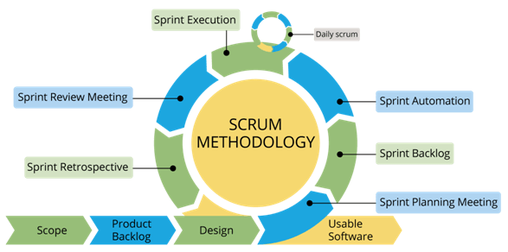**Methodology:**

**Figure 1: Scrum Model Diagram**

We have selected Scum Model for our app. Selection of this methodology as we are developing in increment forms so if change required after result would be easy to implement. As it is incremental based so we can add or remove some features according to needs. We can also change the procedure to perform a function when needed if it doesn’t fit in our system.Different modules can be linked and used as a system in this way and it would be easy to add new features to the existing system.As this model is incremental as well as iterative so this best fits for our project because we have to make changes in our project according to need and we have to develop project in different parts/increments. As this makes the development easy and allow to make changes easily without disturbing the whole project. Adding new feature and enhancement of features is easy in this model.

## 4.1 Activity Diagram

In this diagram we are showing the graphical representation of workflow of stepwise activities. Overall control of flow is shown in this diagram. Activity diagrams are formed with a smaller number of shapes. The important shapes are:

* Action represented with rectangle.
* Decision represented with diamond.
* Start or end are represented with roundel rectangle.
* Arrows show the order of activities in which they are happening.

### 4.1.1 Activity Diagram of App

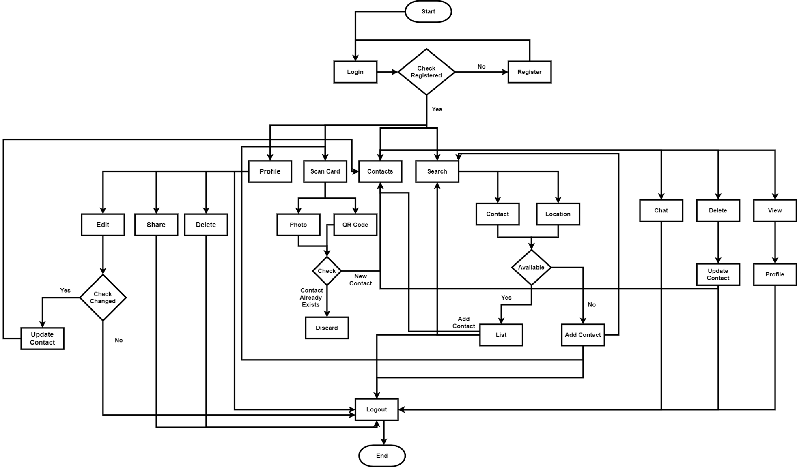

**Figure 2: Activity Diagrams**

This Activity diagram shows the working of the app. In this diagram it is clearly shown that first the user will login to the system and the system will check whether the user is registered or not if the user is not register, he/she has to register first so that user can use the app. If the user is already registered it will login into his profile and the homepage would be shown to him where the user has the options of OCR, QR Code, Contact, Chat, Search, Notifications, Nav bar for additional features so that the user can share and save his details.The user will also be provided with the option of upload from where user can upload his own business cards and share it with the users on the app and outside the app. User can scan card using OCR or QR code and store information directly on the contacts. User can also chat with the community. User would be provided with recommendations based on his interest and trending’s.User can also search for certain business or profile registered on the app. User would also be notified for the changes and updates in the contacts of businesses through notification option.

## 4.2 Use Case Diagram

Use case diagram is used to briefly discuss the requirement of the system. It includes actors, system, user and actions performed by the specified actors. This methodology is used for system analysis and it helps in identifying, clarifying and organizing the system requirements. In our application there are two actors.

* User
* Admin

Use case diagram contains the following components:

* The boundary is used for identifying the system related with the system actors, users.
* According to the roles the actors are individually involved in the system.
* Use case defines the relationship amongst and between the actors.

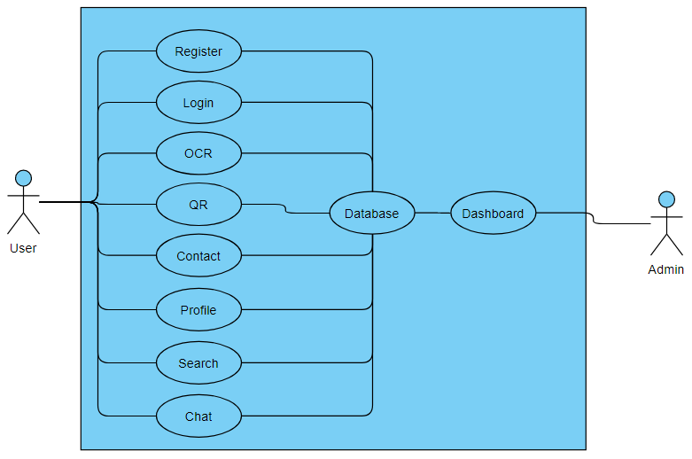

**Figure 3: Use Case Diagram**

This use case diagram shows the interaction of the user with the app. It shows that the use can register on the app, User can Login on the app, User can use OCR to scan and save contacts on the app, User can use QR code to scan and save contacts on the app if available on the card, User can view contact details that are stored on his profile, User can view and edit his profile on the app and can share it with others across the app, User can also search for the new businesses according to his needs and search can be based on Location, Business name, User can also chat with the community to get his doubts and queries solved. All this information would be stored in the database as well as will be retrieved from there. There is an admin also which will manage the database and will look for the information to be added and deleted from the database. Admin will also make changes in the app according to the need of the time. Admin will also have the admin panel/ dashboard from where he will manage all the app database.

## 4.3Sequence Diagram

A sequence diagram is explained in the sequential events of the software system. It is represented through parallel lines which shows the occurring events and at starting and ending have to horizontal lines which shows the system and user respectively.

### 4.3.1 Sequence Diagram of User

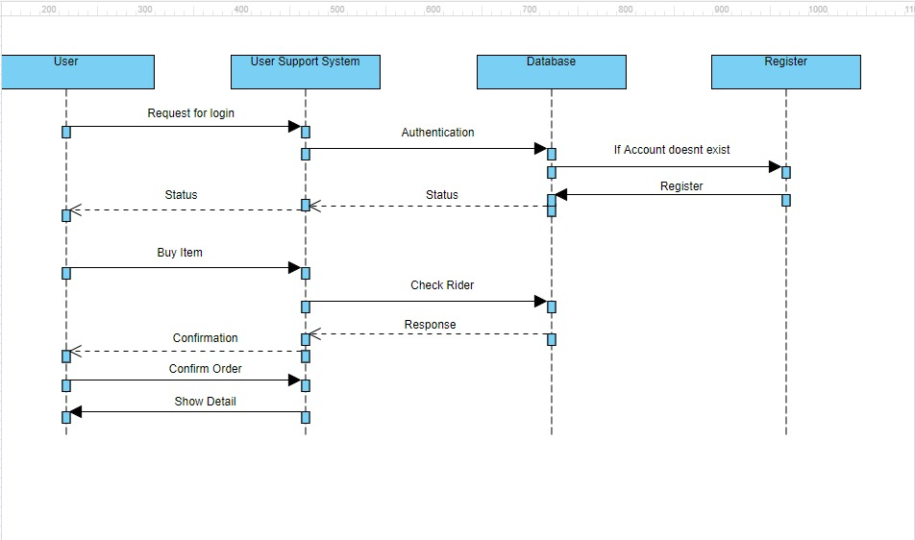

**Figure 4: Sequence Diagram of User Login**

This Sequence diagram shows how the use will interact with the app if he/she is new user. Initially Users will register/login themselves. If the user details are valid according to database, then his account will be opened else the user has to register first. The user will be able to register himself through registration form which is very simple to fill. When the user fills the form and clicks the register button the data for the form will be stored in the database and when for the first-time new user will login it will generate a confirmation email from which the user has to confirm his email first in order to login to the app. When the user verifies the email, he/she can easily login to the app and next time the user will not have to confirm email to login they can directly login to the app through his login details.

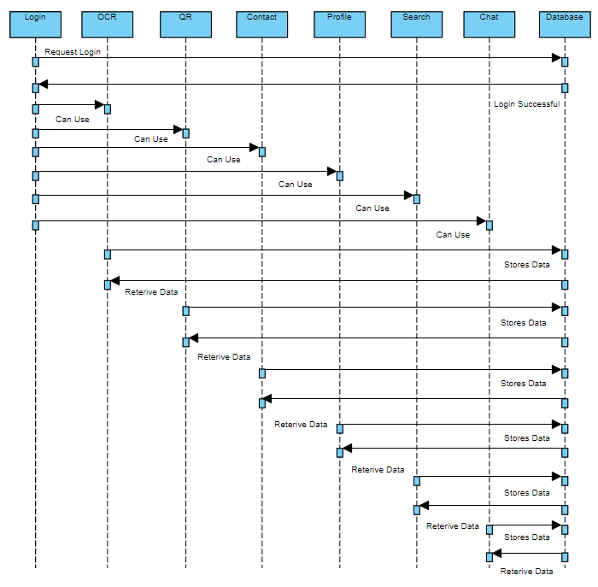

**Figure 5: Sequence Diagram of Registered User**

This sequence diagram shows that userwill login first. In response system will check the details and will allow them to login to the app. After that user will have the access to the homepage where the user has all the options available such as: OCR,QR,Chat,Contact,Profile,Search, Notifications, Nav bar for additional features so that the user can share and save his details. The user will also be provided with the option of upload from where user can upload his own business cards and share it with the users on the app and outside the app. User can scan card using OCR or QR code and store information directly on the contacts. User can also chat with the community. User would be provided with recommendations based on his interest and trending’s. User can also search for certain business or profile registered on the app. User would also be notified for the changes and updates in the contacts of businesses through notification option. The database would be used to store and retrieve information from. It would provide recommendations to the users also and those recommendations would be based on user interest and trending businesses nearby user locations.

## 4.4 Context Diagram

Context diagram explains the initial level of the software system, which can be further divided into sub portions. In short context, the diagram shows the brief picture of system and its relationship with other entities.

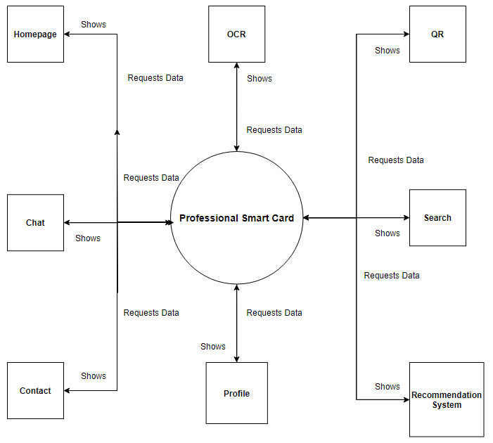

**Figure 6: Context Diagram**

In this Context diagram the overall app is shown and its modules are shown.User will login and select option which user wants. After user have to selected the option, the relevant operation would be performed. The user will have all the options available at the homepage of the app which will allow user to use any option user needed. Further more options are available in the navigation bar at the left most top of the homepage and search and notifications option at the right most top of the homepage. The main modules are present in the homepage and where user will perform all his functions like OCR, QR code, Chat, Contact, Search, Notification, Recommendations, Profile. Nav bar is also present on the homepage from where you can share and edit your details and manage your profile and data.

## 4.5System Architecture Diagram

System Architecture Diagram is used to define the overall working of the system. It is used to tell how the system works when the user interacts with it and what are the basic steps that are taken when a user interacts with the system.

**Figure 7: System Architecture Diagram**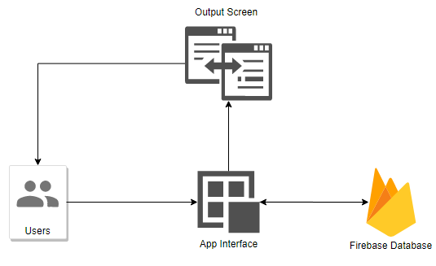

This system architecture diagram shows the basic operations a user will perform while interacting with the app. First the user will login and select option which user wants. After user have to selected the option, the relevant operation would be performed. The user will have all the options available at the homepage of the app which will allow user to use any option user needed. Further more options are available in the navigation bar at the left most top of the homepage and search and notifications option at the right most top of the homepage. When the user selects any option from there it will interact with the app and the app will then interact with the database and get that information from the database and the database will send the information to the app and then the app will display it to the user on the screen.

## 4.6 Conclusion

In this chapter we discuss all the project design which include the activity diagram, use case diagram, sequence diagram, context diagram and system architecture diagram. All these diagrams explain our project design which we discuss in this chapter. Activity diagram show stepwise explanation of the activities. Sequence diagram show sequential explanation of the system. Use case diagram show the requirements of the system. Context diagram show the initial level of the system. System Architecture Diagrams shows the overall working of the system.